AR/VR ASSIGNMENT – 1

The goal of this project was to demonstrate 3 Degrees of Freedom (3DoF) rotation across the X, Y, and Z axes using a 3D object. I used a cube for the demonstration.
TASK 1:
I created a simple 3D environment using Three.js and HTML. A rotating cube was placed inside the scene to demonstrate rotation across the X, Y, and Z axes. The cube continuously rotates on all three axes using an animation loop.
The application also includes:
- Rotation controls
- Auto rotation feature
- VR compatibility using WebXR
The scene was designed with lighting and a virtual environment to improve the visual appearance of the object.
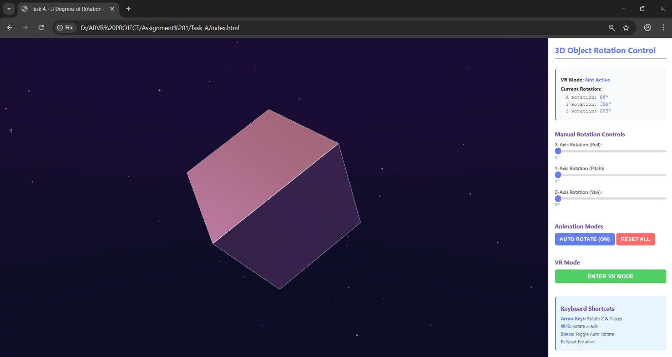
Technologies Used:
- HTML
- CSS
- JavaScript
- Three.js
- WebXR

Conclusion
This project successfully demonstrates 3 Degrees of Rotation using Three.js in a VR-compatible web application. The cube rotates smoothly across all three axes and the interface supports user interaction and immersive viewing.

TASK 2:
I created a marker-based AR application using A-Frame and AR.js. The application detects the Hiro marker through the device camera and displays a rotating 3D cube anchored on top of the marker.
The cube continuously rotates across the X, Y, and Z axes using animation properties in A-Frame. The AR scene updates in real time according to the movement and orientation of the marker.
The application also includes:
- Hiro marker detection
- Real-time 3D object tracking
- Continuous cube rotation
- Camera-based AR experience
- WebXR compatibility
The interface was designed with an information panel and lighting setup to improve the AR visualization and user experience.
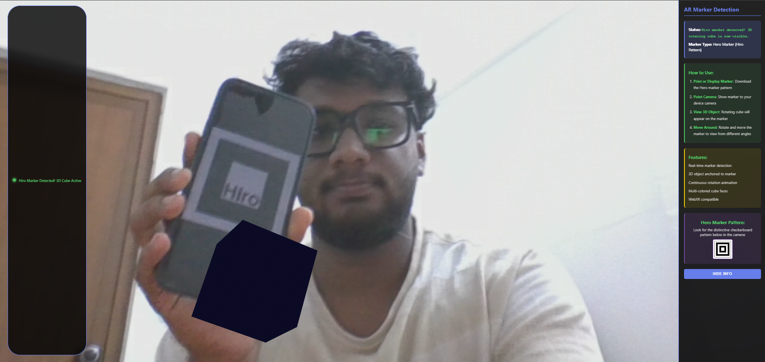
Technologies Used:
- HTML
- CSS
- JavaScript
- A-Frame
- AR.js
- WebXR

Conclusion
This project successfully demonstrates Marker-Based Augmented Reality using A-Frame and AR.js. The rotating cube appears correctly on the Hiro marker and updates dynamically with camera movement. The application provides an interactive AR experience while demonstrating 3 Degrees of Rotation in real time.

